**Neo Bank**

Architecture

Neo Bank would work upon 3 layered architectures

1. Client Side: This would comprise the front-end part which would be actively interacting with the user and receives input and calls the required APIs for the service.
2. Server Side: This would comprise the back-end part which would listen, interpret and handle the requests made by the customers. It would include all the logic and entire working of the Neo Bank.
3. Database: This would store the databases of the customers. It would include their account information, their transaction history. Based on the data the information and other value-added service could be provided to the users. It can search, filter, sort the information based on the request of the users.

The crucial non-functional requirements for the Neo Bank would include security, performance, usability and availability.

Low level Design

Although not yet properly executed by my team, the objects which would be planned include Customer, Profile, Transaction, Record Summary, Services.

Use-Case Diagram

Use-case diagram shows the functionalities and actions which would be possible through the banking system. This includes from both user as well as from the bank server side. Although neo-bank is involved in every action, but some are not connected as it shows an explicit behavior (example transaction takes place through the bank, but the significance it given to the sender and receiver). Some functions of the system would be automated by the bank and manual as well.

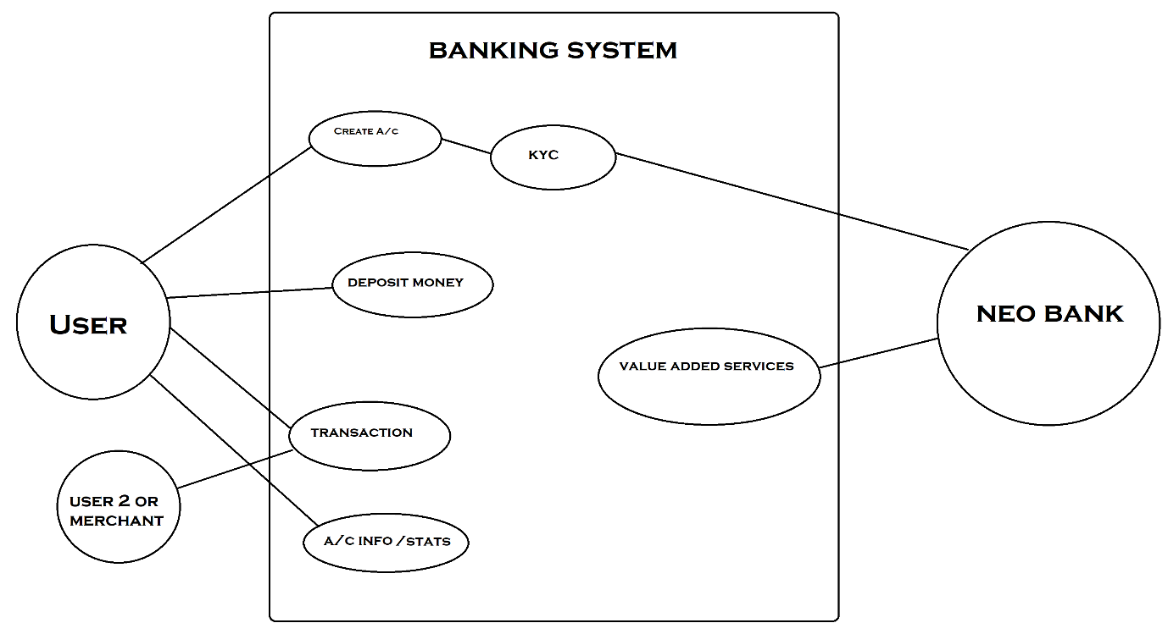

Sequence Diagram

It just includes the procedural steps in a sequential manner to perform the operations by the user such as opening account, fund transfer etc.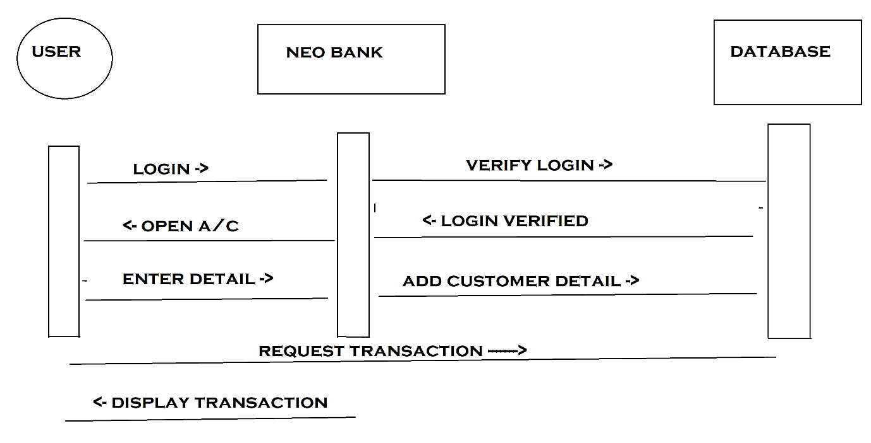

Database Design

The functionality of the database is to store and retrieve the information as per the user request and present it when required. The main aspects of a ideal database should be the size, speed (low latency), scalability and a stable structure. Data integrity is also a key requirement. SQL based databases would be used to query and sort the data as desired by the user.